**MentorU**

**A PROJECT REPORT**

**for**

**Mini Project (KCA353)**

**Group Number: GA05**

**Session (2023-24)**

**Submitted by**

**ABHISHEK PANDEY**

**2200290140010**

**AJAY SINGH YADAV**

**2200290140014**

**Submitted in partial fulfilment of the**

**Requirements for the Degree of**

**MASTER OF COMPUTER APPLICATION**

**Under the Supervision of**

**Ms. Neelam Rawat**

### Associate Professor



**Submitted to**

**Department Of Computer Applications**

**KIET Group of Institutions, Ghaziabad**

**Uttar Pradesh-201206**

**(2023-2024)**

**CERTIFICATE**

Certified that **Abhishek Pandey 220029014007566, Ajay Singh Yadav 220029014003679** has/have carried out the project work having “**MentorU**” (**Mini Project-KCA353**) for **Master of Computer Application** from Dr. A.P.J. Abdul Kalam Technical University (AKTU**)** (formerly UPTU), Lucknow under my supervision. The project report embodies original work, and studies are carried out by the student himself/herself and the contents of the project report do not form the basis for the award of any other degree to the candidate or to anybody else from this or any other University/Institution.

**Date:**

**03/01/2024 Abhishek Pandey (2200290140010)**

**Ajay Singh Yadav (2200290140014)**

This is to certify that the above statement made by the candidate is correct to the best of my knowledge.

Date:

**Ms. Neelam Rawat Dr. Arun Tripathi**

**Associate Professor Head**

**Department of Computer Applications Department of Computer Applications**

**KIET Group of Institutions, Ghaziabad KIET Group of Institutions, Ghaziabad**

**ABSTRACT**

In the realm of academia, effective mentorship plays a pivotal role in shaping the educational journey of students. MentorU emerges as a groundbreaking project, addressing the intricate dynamics of mentorship within the academic community. The cornerstone of MentorU lies in its meticulously crafted login system, catering to both mentors and mentees. Upon mentor login, the platform empowers mentors to curate their mentorship portfolio by adding students as mentees. This initiates a transformative process where mentors can actively engage with the academic and professional progress of their mentees, offering personalized insights and responses to queries.

Mentors wield a comprehensive toolkit within MentorU, encompassing the ability to provide remarks, schedule future mentoring sessions, and foster a collaborative learning environment. The platform goes beyond conventional mentorship models, introducing a dynamic feedback loop that enriches the mentor-mentee relationship. On the mentee side, the login provides a gateway to a wealth of information, showcasing their academic and professional journey. Through MentorU, mentees gain the ability to submit queries, creating a platform for proactive engagement with their mentors.

A distinctive feature of MentorU lies in its seamless integration of technology, enabling scheduled mentorship sessions through Google Meet. This not only transcends geographical constraints but also enhances the accessibility and effectiveness of mentorship interactions.

MentorU, at its core, seeks to redefine the mentorship paradigm by amalgamating technological innovation with educational guidance. The project is envisioned as more than just a platform; it is a catalyst for fostering meaningful connections, promoting academic growth, and cultivating a collaborative community within the academic landscape. MentorU stands poised to be a transformative force, revolutionizing the mentorship experience and contributing to the holistic development of students in the pursuit of knowledge.

**ACKNOWLEDGEMENTS**

Success in life is never attained single-handedly. My deepest gratitude goes to my project supervisor, **Ms. Neelam Rawat** for his/ her guidance, help, and encouragement throughout my project work. Their enlightening ideas, comments, and suggestions.

Words are not enough to express my gratitude to Dr. Arun Kumar Tripathi, Professor and Head, Department of Computer Applications, for his insightful comments and administrative help on various occasions.

Fortunately, I have many understanding friends, who have helped me a lot on many critical conditions.

Finally, my sincere thanks go to my family members and all those who have directly and indirectly provided me with moral support and other kinds of help. Without their support, completion of this work would not have been possible in time. They keep my life filled with enjoyment and happiness.

**Abhishek Pandey**

**Ajay Singh Yadav**

**TABLE OF CONTENTS**

|  |  |  |  |  |  |
| --- | --- | --- | --- | --- | --- |
|  | Certificate | | | i | |
|  | Abstract | | | ii | |
|  | Acknowledgements | | | iii | |
|  | Table of Contents | | | iv | |
|  | List of Figures | | | xiii | |
| 1 | Introduction | | | 1-4 | |
|  | 1.1 | Overview | | 1 | |
|  | 1.2 | Objective | | 2 | |
|  | 1.3 | Technical foundations | | 2 | |
|  | 1.4 | Communication model | | 2 | |
|  | 1.5 | Data-driven mentorship | | 2 | |
|  | 1.6 | Project Requirement | | 3 | |
|  | 1.7 | Background | | 4 | |
| 2 | Feasibility Study | | | 5-7 | |
|  | 2.1 | Economical Feasibility | | 5 | |
|  | 2.2 | Technical Feasibility | | 6 | |
|  | 2.3 | Operational Feasibility | | 7 | |
| 3 | System Requirements | | | 8-12 | |
|  | 3.1 Functional Requirement | | | 8 | |
|  | 3.2 Non-Functional Requirement | | | 9 | |
|  | 3.3 Design Goal | | | 10 | |
| 4 | System analysis and design | | | 13-17 | |
|  | 4.1 System analysis | | | 13 | |
|  | 4.2 | System Design | | 13 | |
|  | 4.3 | Database | | 15 | |
| 5 System implementation and figures | | | 18-32 | |
| 6 Conclusion | | | 33 | |
| 7 | Bibliography | | | 34 | |
|  |  | | |  | |

**List of Figures**

|  |  |  |  |
| --- | --- | --- | --- |
| **Figure No.** | **Name of Figure** | **Page No.** | |
| 3.1 | Use Case Diagram 12 | |
| 3.2 | DFD Diagram 13 | |
| 4.1 | Mentor DB 16 | |
| 4.2 | Student DB 16 | |
| 4.3 | Counselling record DB 16 | |
| 4.4 | Mark DB 17 | |
| 4.5 | Request Response DB 17 | |
| 5.1 | Login Page 18 | |
| 5.2 | Mentor Registration Page 19 | |
| 5.3 | Mentor Dashboard 21 | |
| 5.4 | Add Mentee Details 22 | |
| 5.5 | Add Mentee 23 | |
| 5.6 | Add Marks 25 | |
| 5.7 | Add Parent Details 26 | |
| 5.8 | Profile Links 27 | |
| 5.9 | Mentees List 28 | |
| 5.10 | Mentee Details 29 | |
| 5.11 | Mentee Dashboard 31 | |
|  |  | |

**CHAPTER 1**

**INTRODUCTION**

* 1. **OVERVIEW**

In the rapidly evolving landscape of education and professional development, the critical demand for personalized guidance and mentorship has reached unprecedented levels. Recognizing and responding to this imperative need, "MentorU" emerges as an innovative online mentorship platform. This visionary initiative is meticulously designed to transcend traditional mentorship models, creating a dynamic and interactive virtual environment where mentors and mentees can forge meaningful connections, fostering holistic growth and development.

MentorU serves as a groundbreaking nexus at the intersection of technology and mentorship philosophy. The platform redefines conventional mentorship by providing a tailored solution that adapts to the evolving needs of students and professionals. The core ethos centres around creating a collaborative and engaging virtual space, where mentor-mentee relationships extend beyond academic realms to encompass the broader spectrum of personal and professional development. Through a user-centric interface, MentorU offers features ranging from personalized mentorship matching algorithms to dynamic progress tracking tools, reshaping the essence of mentorship in the digital age.

Positioned as a trailblazer, MentorU responds to the nuanced needs of a diverse and globalized community of learners and professionals. This transformative ecosystem stands as a testament to the potential of online mentorship platforms, ushering in an era of personalized, adaptive, and impactful mentorship experiences. MentorU is not just a platform; it is a catalyst for educational and professional empowerment, poised to make a lasting impact on the trajectory of individuals' growth and success in an interconnected world.

**1.2 OBJECTIVES**

**1.2.1 Facilitating Meaningful Connections:**

MentorU aims to bridge the gap between experienced mentors and enthusiastic mentees, creating a space where valuable insights and knowledge can be shared. The platform prioritizes the establishment of meaningful connections that go beyond traditional mentoring boundaries.

**1.2.2 Academic Performance Insight:**

Mentors on the MentorU platform gain access to comprehensive data, including academic performance, attendance records, and other relevant metrics of their mentees. This data-driven approach allows mentors to tailor their guidance to the unique needs of each mentee.

**1.2.3 Empowering Mentees:**

MentorU empowers mentees by providing them with a platform to seek guidance, ask questions, and receive constructive feedback from their mentors. The platform facilitates an open and collaborative space for mentees to actively engage in their educational and professional growth.

**1.3** **TECHNICAL FOUNDATIONS**

Built on a robust computer network infrastructure, MentorU ensures seamless communication between mentors and mentees. The platform adheres to essential network criteria, including high performance, reliability, and scalability, to offer a dependable and scalable environment for mentorship interactions.

**1.4 COMMUNICATION MODEL**

MentorU adopts a sophisticated communication model that enables efficient data exchange between mentors and mentees. This model supports various devices, including computers, tablets, and smartphones, providing flexibility and accessibility for all users.

**1.5 DATA-DRIVEN MENTORSHIP**

Data communication lies at the heart of MentorU, facilitating the exchange of information between mentors and mentees. The platform categorizes data communication into two types:

**1.5.1 Personalized Local Communication:**

Within the same educational institution or geographical area, MentorU encourages face-to-face interactions, fostering a personalized mentorship experience.

**1.5.2 Seamless Remote Communication:**

For scenarios where mentors and mentees are separated by distance, MentorU ensures effective and timely remote communication. Key features of successful data communication, including accurate data delivery, timeliness, and precision, are central to the platform's design.

As this project unfolds in subsequent chapters, we explore the intricate details of MentorU architecture, functionalities, and user experience. MentorU envisions not only connecting mentors and mentees but also revolutionizing the mentorship landscape by leveraging cutting-edge technology and fostering a collaborative community dedicated to academic and professional excellence.

**1.6 PROJECT REQUIREMENTS**

**1.6.1 Hardware:**

* Processor: Minimum 2.0GHz requires.
* Ram: 2 GB.
* Hard Disk: 100 GB.
* Input device: Standard Keyboard and Mouse.
* Output device: VGA and High, Resolution Monitor.

**1.6.2 Software:**

* Operating System: Windows 7
* Language: PHP, JAVASCRIPT
* Database: phpMyAdmin.
* Tool: Visual Studio, XAMPP.

**1.7 BACKGROUND:**

In the dynamic realm of education, MentorU emerges as a pioneering platform designed to revolutionize the traditional mentorship paradigm. As the educational landscape undergoes transformative shifts, MentorU acknowledges the need for an innovative approach to mentorship, transcending the conventional methods.

MentorU recognizes that the success of any educational platform lies in understanding and analysing user behaviour. In this context, the platform strives to provide a seamless and enriching experience for both mentors and mentees. The primary focus is on fostering meaningful connections within the college community, addressing the challenges students often face in navigating their academic journey.

Unlike traditional mentorship models, MentorU leverages technology to bridge the gap between mentors and mentees. Through a meticulously crafted online platform, MentorU facilitates mentor-mentee relationships, allowing for effective guidance, support, and the exchange of valuable insights. The platform's user-friendly interface empowers mentors to monitor and enhance their mentees' academic and professional progress.

The educational landscape is evolving, marked by the diversified and sophisticated demands of students in the era of globalization. MentorU acknowledges the pivotal role of students as key drivers in educational advancement. The platform aims to align with these changes, offering a dynamic solution to the evolving needs of students seeking mentorship and guidance.

In essence, MentorU represents a shift towards a more modern, accessible, and tailored approach to mentorship, fostering a community where knowledge, support, and collaboration flourish. The platform's commitment is to create an environment where mentorship transcends traditional boundaries, promoting student success in the fast-paced educational journey.

**CHAPTER 2**

**FEASIBILITY STUDY**

Feasibility is defined as the practical extent to which a project can be performed successfully. To evaluate feasibility, a feasibility study is performed, which determines whether the solution considered to accomplish the requirements is practical and workable in the software. Information such as resource availability, cost estimation for software development, benefits of the software to the organization after it is developed and cost to be incurred on its maintenance are considered during the feasibility study. The objective of the feasibility study is to establish the reasons for developing the software that is acceptable to users, adaptable to change and conformable to established standards.

**2.1 Economic Feasibility**:

Economic Feasibility means the cost of understanding project should less cost than the existing system. Electronic mailing system is economically feasible, because it reduces the expenses in the system.

Economic feasibility evaluates the financial viability of a proposed project or initiative. It entails analysing various factors such as costs, revenue projections, return on investment (ROI), and potential risks. By assessing these elements, stakeholders can determine whether the project is economically sound and worth pursuing. Economic feasibility studies help in making informed decisions, guiding resource allocation, and mitigating financial risks. They provide valuable insights into the project's profitability, sustainability, and long-term impact on the organization's financial health. Ultimately, economic feasibility serves as a crucial determinant in evaluating the feasibility and potential success of a project in the marketplace.

Economic feasibility involves study to establish the cost benefit analysis. Money spent on the system must be recorded in the form of benefit from the system. The benefits are of two types:

**2.2.1 Tangible benefits:**

• Saving man labour to do tedious tasks saves time.

**2.2.2 Intangible benefits:**

• Improves the quality of organization.

**2.2 Technical Feasibility:**

This study is carried out to check the technical feasibility, that is, the technical requirements of the system. Any system developed must not have a high demand on the available technical resources. This will lead to high demands being placed on the client. The developed system must have a modest requirement, as only minimal or null changes for the implementing this system.

The technical feasibility of MentorU is meticulously assessed to ensure a robust and scalable system that aligns with the project's objectives. The platform is designed with a focus on leveraging technology to provide a seamless and secure environment for mentor-mentee interactions. The implementation of regular data backups, disaster recovery plans, and a thoughtful technology stack contributes to the overall reliability and sustainability of MentorU. Cost analysis considerations further underscore the project's pragmatic approach to resource utilization and long-term viability. Key aspects of the technical feasibility study include:

**Scalable and Secure Architecture: MentorU’s** technical framework is underpinned by a scalable architecture, ensuring it can handle a growing user base without compromising performance. The platform implements load balancing and performance optimization strategies to maintain responsiveness and efficiency even as user numbers increase.

**Secure User Authentication and Data Transmission:** Security is a paramount consideration in MentorU's technical design. The platform features a secure user authentication system, safeguarding user accounts. Data transmission is encrypted to protect sensitive information, prioritizing user privacy and data security.

**Real-time Communication Integration: MentorU** integrates seamlessly with communication tools like Google Meet, facilitating real-time interactions during scheduled mentorship sessions. This ensures a dynamic and interactive mentoring experience for both mentors and mentees.

**Intuitive and Responsive User Interface:** A user-friendly and responsive interface is at the forefront of MentorU's technical design. The platform prioritizes an intuitive layout that adapts to various devices and browsers, providing a consistent and accessible experience for all users.

**Data Backup and Disaster Recovery:** MentorU places emphasis on data integrity and continuity. Regular data backups and a comprehensive disaster recovery plan are implemented to safeguard against data loss and ensure the platform's reliability in unforeseen circumstances.

MentorU's technical feasibility study affirms its commitment to providing a secure, scalable, and user-friendly mentoring platform. The implementation of advanced technological features, coupled with strategic resource management, positions MentorU as a sustainable solution for effective mentor-mentee engagements in the educational landscape.

**2.3 Operational Feasibility:**

MentorU has undergone a comprehensive operational feasibility study to ensure its seamless integration into existing educational and professional landscapes. The platform's design philosophy prioritizes user acceptance through a user-friendly interface, efficient onboarding processes, and adaptability to diverse settings. With streamlined administrative workflows, including automated scheduling and centralized progress tracking, MentorU is positioned to enhance operational efficiency, saving time for both users and administrators. Its compatibility with widely used communication tools adds a practical layer, fostering effective collaboration and communication within the mentorship ecosystem.

**User-Centric Design and Adaptability:** MentorU's operational feasibility is anchored in its user-centric design, providing an intuitive interface that minimizes the learning curve for mentors and mentees. The platform's adaptability ensures it seamlessly integrates into various educational and professional settings, aligning with diverse operational needs. Whether deployed in academic institutions or corporate environments, MentorU is designed to complement existing processes, contributing to a positive user experience and facilitating smooth operational transitions.

**Efficiency and Time Savings:** The operational efficiency of MentorU is underscored by its streamlined administrative processes, optimizing tasks such as scheduling and progress tracking. By automating these workflows, MentorU reduces manual efforts, allowing stakeholders to focus more on meaningful mentorship interactions and less on administrative overhead. This emphasis on time savings enhances the practical value of MentorU, making it an asset in advancing academic and professional development within the operational contexts it serves.

**Practical Value and Collaborative Communication:** MentorU's operational feasibility extends to its practical value in fostering meaningful mentorship relationships. The platform's compatibility with widely used communication tools enhances collaborative communication between mentors and mentees. This seamless integration ensures effective interaction, contributing to MentorU's role as a practical and valuable solution for stakeholders seeking to elevate mentorship programs within their operational frameworks.

**CHAPTER 4**

**SYSTEM REQUIREMENT**

System requirements refer to the specifications and capabilities that a computer system, software application, or hardware device must meet or exceed to effectively perform its intended functions. These requirements are typically defined during the planning and design phase of a project and serve as guidelines for system development, deployment, and operation.

Functional and non-functional requirements are two essential types of specifications that define the features and characteristics of a system, such as an online mentorship web application.

**3.1 Functional requirements:**

Functional requirements define the specific functionalities or features that a software system must provide to meet the needs of its users and fulfil its intended purpose. These requirements describe what the system should do in terms of inputs, processes, and outputs. Here's a more detailed explanation of functional requirements in the context of an online mentorship web application.

**User Registration:** MentorU should allow users, both mentors, and mentees, to create accounts with unique usernames and secure passwords. The registration process involves capturing necessary user information, validating input data, and securely storing user credentials in the system.

**Profile Management:** The system must support the creation and management of detailed profiles for both mentors and mentees. This includes capturing academic and professional details, personal information, and optional profile links (e.g., LinkedIn, GitHub) for mentees.

**Academic and Professional Progress Tracking:** Mentors should be able to track the academic and professional progress of their mentees. This involves features to input and view mentee's academic achievements, career milestones, and any other relevant progress.

**Query Management:** Mentees should be able to submit queries or questions to their mentors within the platform. Mentors can review, respond to queries, and provide guidance or feedback.

**Scheduling Mentoring Sessions:** The system should enable mentors to schedule mentoring sessions with their mentees. This includes features for selecting session times, sending session invitations, and receiving mentee responses.

**User Authentication and Security:** Users, both mentors, and mentees, should be able to log in securely, access their accounts, and log out when needed. The system should implement robust user authentication, session management, and password security measures to protect against unauthorized.

**3.2 Non-Functional Requirement:**

Non-functional requirements, also known as quality attributes or system attributes, define the attributes or characteristics of a software system that are not directly related to its functionality but are crucial for ensuring its overall quality, performance, and user experience. Let's delve deeper into each non-functional requirement for an online mentorship web application and add some related content.

**Performance:** MentorU must exhibit optimal response times for user actions, such as loading user profiles, accessing mentoring sessions, and submitting queries. Performance testing will validate the system's responsiveness under various conditions to meet expectations during peak usage.

**Scalability:** Scalability in MentorU ensures the system can handle increased user activity and data growth as the user base expands. The platform should scale horizontally or vertically to accommodate additional mentors, mentees, and mentoring sessions without compromising performance.

**Reliability:** Reliability guarantees consistent and predictable operation of MentorU with minimal downtime. The platform should implement fault-tolerant mechanisms, redundant infrastructure, and automated failover processes to ensure continuous availability and quick recovery from potential failures.

Security: Security is a priority for MentorU to protect user data, including personal and academic information. This involves implementing encryption, robust access controls, authentication mechanisms, and secure communication protocols to safeguard sensitive information.

**Usability:** Usability in MentorU focuses on creating an intuitive and user-friendly interface for both mentors and mentees. Usability testing will identify areas for improvement in terms of layout, navigation flow, accessibility features, and responsiveness across different devices.

**User Authentication:** User authentication ensures that only authorized users can access MentorU and its features. This involves implementing strong password policies, multi-factor authentication, session management, and secure logout mechanisms to protect user accounts from unauthorized access.

**Compatibility:** MentorU should be compatible with various web browsers, operating systems, and devices to ensure a consistent user experience across different platforms.

**Maintainability:** The system should be designed and developed in a modular and well-structured manner, facilitating easy maintenance, updates, and extensions over time.

**3.3 Design Goal:**

Our design goal for MentorU is to craft a seamless and user-centric mentoring experience. Emphasizing simplicity and functionality, we aspire to create an intuitive platform that enhances user engagement and satisfaction. Streamlined navigation takes precedence, ensuring mentors and mentees can effortlessly navigate through profiles, mentoring sessions, and communication features. The design will prioritize an enriched mentoring discovery process through visually appealing displays, personalized recommendations, and a well-organized profile and session catalogue.

Our aim is to capture users' interest and facilitate informed decision-making in the mentoring journey. The process of connecting mentors and mentees will be frictionless, emphasizing clarity, user-friendly interfaces, and transparent communication. Ensuring a responsive interface across devices is pivotal, guaranteeing a consistent and enjoyable experience for users accessing MentorU on various platforms.

Performance optimization, encompassing swift loading times and efficient interactions, is integral to sustaining user engagement throughout the mentoring relationship. Aesthetic considerations will contribute to the overall user experience, employing visually pleasing design elements that align with MentorU's brand identity. In conclusion, our design goal is to amalgamate functionality and aesthetics, creating a mentoring platform that not only meets user needs but also exceeds expectations, fostering satisfaction, trust, and long-term loyalty among mentors and mentees.

**Use Case Diagram:**

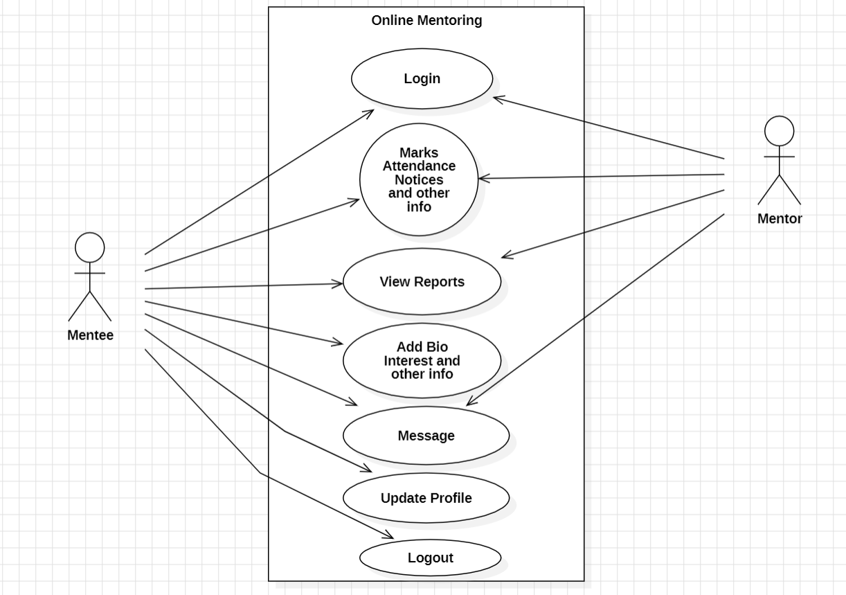

Fig:4.1 Use Case Diagram

**DFD Diagram of Project:**

Fig:4.2 DFD Diagram of Project

**CHAPTER 4**

**SYSTEM ANALYSIS AND DESIGN**

**4.1 System Analysis**

Embarking on the construction of MentorU, a robust distributed client-server computing model has been meticulously laid as the bedrock. Stringent specifications guide the normalization process up to the revered third normal form (3NF), systematically addressing potential anomalies inherent in database transactions undertaken by both general users and organizational administration. The user interfaces, thoughtfully tailored to be browser-specific, ensure a broad and inclusive accessibility spectrum across the entire system.

**Database Infrastructure and Connectivity:**

Central to MentorU's operations is the internal database infrastructure anchored by the SQL Server. Employing strategic constructs such as table spaces, clusters, and indexes, the system aims to elevate data storage consistency and reliability to the highest standards. The utilization of the latest "SQL Connection" technology from Microsoft Corporation ensures seamless connectivity, and stringent authentication and authorization mechanisms are implemented at each stage to fortify system security.

**Front-End Development Validation:**

The front-end development landscape of MentorU is shaped by the robust pairing of HTML and CSS. Here, the focus is keenly directed towards maintaining data consistency through meticulous business rule validations. This ensures that the user interfaces not only meet the aesthetic standards but also adhere rigorously to business rules, contributing to a seamless and reliable user experience.

Through this comprehensive system analysis, MentorU sets forth to establish a technological framework that not only prioritizes security and reliability but also endeavours to provide users with an accessible, consistent, and user-friendly platform for educational mentorship.

**4.2 System Design**

Delving into the intricate dynamics of mentorship within the academic realm, MentorU's system design emerges as a comprehensive and dynamic virtual environment. Analogous to the nuanced operational structure in the seized property Biddings example, MentorU functions as a sophisticated platform connecting mentors and mentees. The mentor-mentee relationship mirrors the buyer-seller dynamics, with mentors providing guidance akin to the buyer's journey. The platform serves as the institutional hub, resembling the Collection Authority, featuring tailored dashboards and interfaces. Just as debtors open accounts, mentors add students as mentees, initiating a collaborative academic journey. The platform seamlessly integrates academic and professional progress tracking, query resolution, and the scheduling of mentorship sessions. The technological integration, including virtual sessions through Google Meet, parallels the procedural use of an Item Profiler, creating standardized user profiles to foster a dynamic and collaborative mentorship environment. Within the MentorU ecosystem, the page layout incorporates digital representations and textual details, elevating the mentorship experience to a comprehensive and reliable academic journey.

**Primary Design Phase:**

In the primary design phase of MentorU, the emphasis is on creating a robust and structured system that aligns with the conceptual requirements identified during the analysis phase.

Block-Level Design: The system is conceptualized at a high level, defining the overall structure by breaking it down into functional blocks. Each block represents a specific module, addressing distinct aspects such as mentor-mentee interaction, academic progress tracking, and session scheduling.

Functionality Mapping: Based on the analysis, blocks are created, mapping identified requirements to functional components. Each block serves a specific purpose within the MentorU system, fostering modularity and maintainability.

Minimizing Information Flow: The design prioritizes minimizing information flow between blocks to enhance modularity. Activities requiring close interaction are grouped together, ensuring efficient encapsulation and maintainability.

High-Level Design Documentation: Comprehensive documentation captures high-level design decisions, block diagrams, data flow diagrams, and other architectural elements. These documents serve as a reference throughout the software development lifecycle.

**Secondary Design Phase:**

The secondary design phase delves deeper into individual blocks identified during the primary design phase.

Detailed Design: The focus shifts to the detailed design of each block, defining internal structure, interfaces, algorithms, data structures, and implementation details. This phase lays the groundwork for efficient functionality within each module.

Refinement and Optimization: Further refinement and optimization of the system architecture occur during this phase. Design decisions consider trade-offs between factors like performance, scalability, flexibility, and maintainability.

Interface Design: Special attention is given to designing clear and well-defined interfaces between different modules, specifying input parameters, output formats, error handling mechanisms, and communication protocols.

Design Review and Validation: Rigorous design reviews involve stakeholders to ensure alignment with project objectives. Feedback is incorporated, validating design decisions and addressing concerns to enhance the overall system design.

User Interface (UI) Design for MentorU:

User Interface (UI) design for MentorU is a comprehensive process focusing on creating an intuitive, visually appealing, and user-friendly environment.

Visual Design: The overall look and feel of MentorU's interface are meticulously crafted, incorporating colour schemes, typography, icons, and graphical elements. The aesthetic appeal is balanced with clarity and readability to shape positive user perceptions.

Layout and Organization: UI designers organize interface elements logically, guiding users through the interaction process. Screens, navigation menus, buttons, and forms are strategically laid out for intuitive navigation and quick access to information.

Information Architecture: Information within MentorU's interface is structured for easy accessibility. This involves categorizing information, creating hierarchies, and defining navigation pathways to facilitate efficient user interaction.

Interaction Design: Detailed attention is given to defining how users interact with the interface, designing interactive elements and user flows that ensure seamless and intuitive interactions, minimizing cognitive load for users.

Usability and Accessibility: MentorU's UI adheres to core principles of usability and accessibility. Design considerations include providing alternative text for images, keyboard shortcuts, screen reader optimization, and compliance with accessibility standards such as WCAG.

Responsive Design: In response to diverse devices and screen sizes, MentorU prioritizes responsive design principles, ensuring a consistent user experience across desktop, tablet, and mobile devices.

Feedback and Error Handling: The UI incorporates feedback mechanisms and error handling strategies to provide clear guidance throughout interactions. Success messages, error alerts, and confirmation prompts keep users informed.

User Testing and Iteration: UI design is an iterative process, gathering feedback through usability testing and user interviews. Designers use this feedback to refine and optimize the interface, addressing usability issues and optimizing the user experience over time.

The meticulous design of MentorU's system and user interface ensures a robust foundation for effective mentor-mentee interactions, academic progress tracking, and seamless usability, ultimately meeting the expectations of both users and stakeholders in the educational landscape.

**4.3 Database:**

The data in the system must be stored and retrieved from the database. Designing the database is part of system design. Data elements and data structures to be stored have been identified at analysis stage. They are structured and put together to design the data storage and retrieval system.

A database is a collection of interrelated data stored with minimum redundancy to serve many users quickly and efficiently. The general objective is to make database access easy, quick, inexpensive, and flexible for the user. Relationships are established between the data items and unnecessary data items are removed. Normalization is done to get an internal consistency of data and to have minimum redundancy and maximum stability. This ensures minimizing data storage required, minimizing chances of data inconsistencies, and optimizing for updates. This theoretical representation of the data is called an ontology.

**Database Tables**

**Mentor DB:**

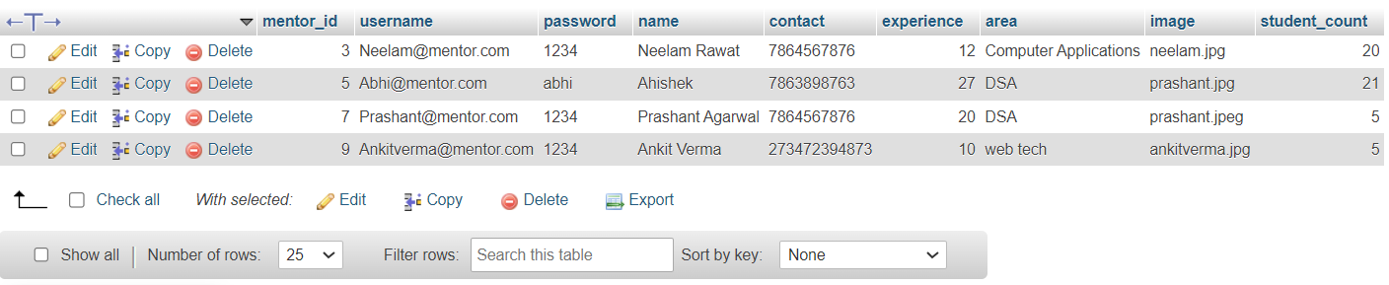

Fig:3.1 Mentor DB

**Student DB:**

Fig:3.2 Student DB

**Counselling records DB:**

Fig:3.3 Counselling records DB

**Marks DB:**

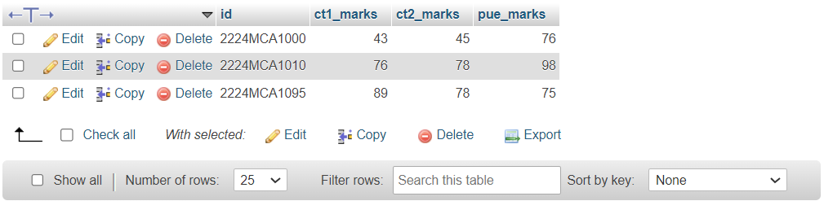

Fig:3.4 Marks DB

**Request Response DB:**

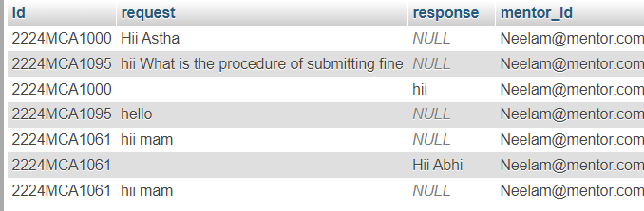

Fig:3.5 Request Response DB

CHAPTER 5

SYSTEM IMPLEMENTATION AND FIGURES

**Login Page:**

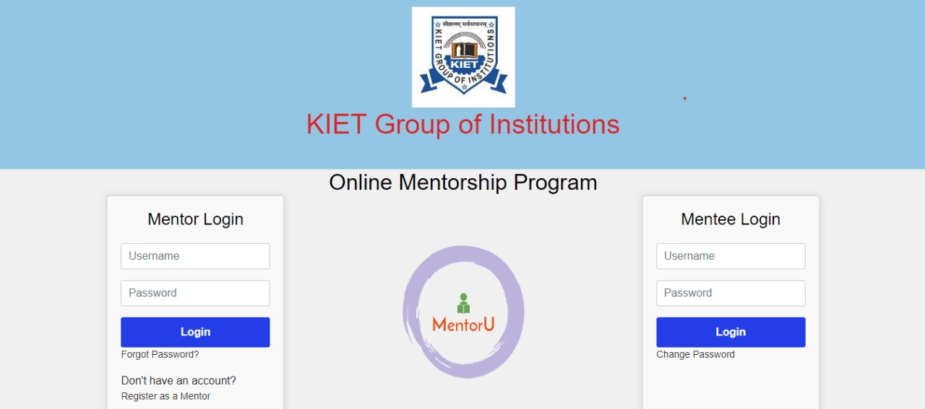

Fig:5.1 Login page

Both mentors and mentees enter their respective usernames and passwords to access their dashboards.

**"Forgot Password" Link:**

A "Forgot Password" link is available for users who need to reset their password. Clicking this link guides them through the password recovery process.

**"Register as a Mentor" Link:**

Mentors have an option to register for a new account directly from the login page. A "Register as a Mentor" link directs them to the mentor registration form.

**"Login" Button:**

A "Login" button allows users to submit their credentials and access their dashboard.

**Dashboard:**

User Details:

Upon login, both mentors and mentees are greeted with an overview of their profile details, including name, profile image, and relevant information.

**Mentor Registration Page:**

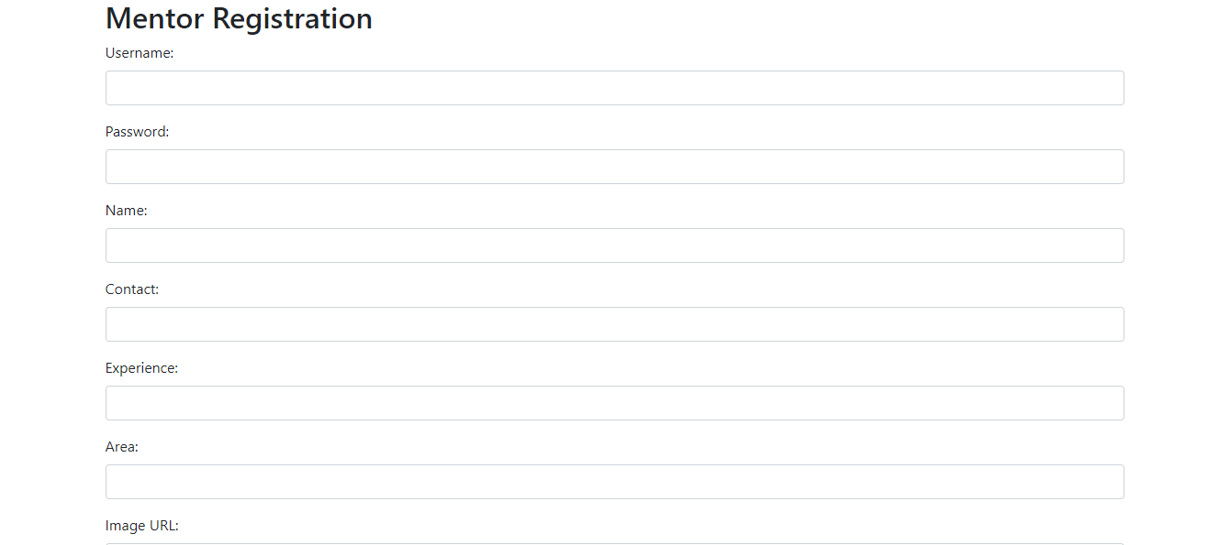

Fig:5.2 Mentor Registration Page

**1. Username:**

Type: Text input

Label: Choose a Username

Description: Unique identifier for the user's account.

**2. Password:**

Type: Password input

Label: Create a Password

Description: Secure password to protect the account. Consider including guidelines for a strong password.

**3. Name:**

Type: Text input

Label: Enter Your Full Name

Description: User should input their complete name.

**4. Contact:**

Type: Text input

Label: Enter Your Phone Number

Description: User's contact number. You may include a format example for clarity.

**5. Experience:**

Type: Number input or Dropdown menu

Label: Enter Your Years of Experience

Description: User should input the number of years of professional experience. Alternatively, provide a dropdown menu with predefined experience ranges.

**5. Area:**

Type: Text input or Dropdown menu

Label: Specify Your Areas of Expertise

Description: User can input or select their specific fields or subjects of expertise. For a dropdown menu, offer predefined options or allow free-text entry.

**6. Image URL:**

Type: Text input

Label: Provide a Profile Image URL (Optional)

Description: User can optionally input a URL linking to their professional profile image. This image will be displayed on the MentorU platform.

**Additional considerations:**

* Validation: Implement validation checks for each field (e.g., ensuring the phone number is in the correct format, password strength requirements).
* Submit Button: A button labelled "Login" to submit the form.
* Error Handling: Display clear error messages if the user enters information incorrectly.
* Remember to design the registration page with a user-friendly interface to enhance the overall user experience.

**Mentor Dashboard:**

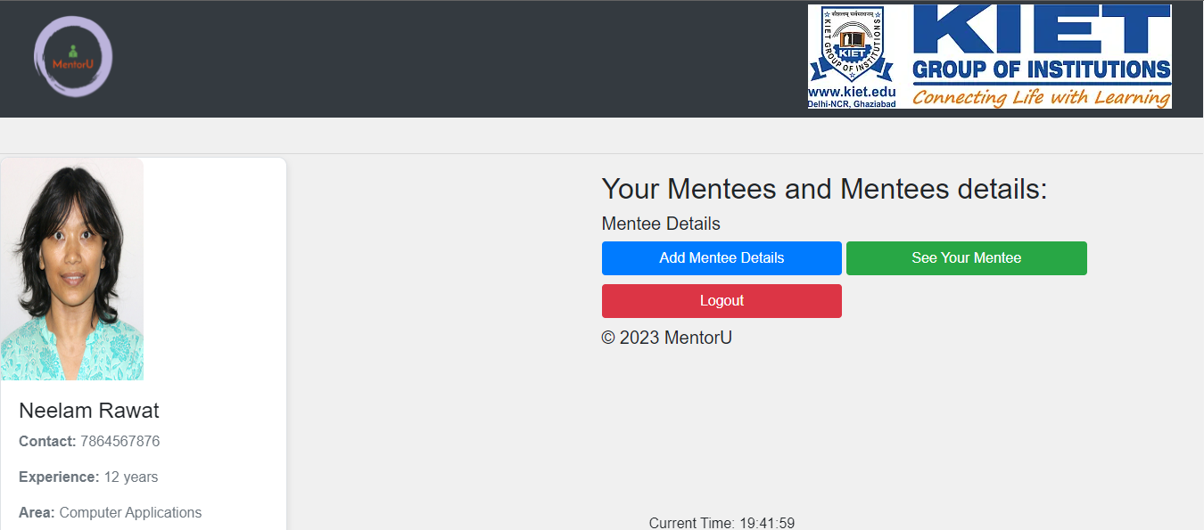

Fig:5.3 Mentor Dashboard

Upon logging in, mentors are welcomed to their personalized dashboard, providing a centralized space to manage mentorship activities.

**1. Mentor Details:**

Overview Section: The dashboard prominently displays mentor details, including the mentor's name, profile image, years of experience, and areas of expertise. This section serves as a quick reference to the mentor's profile.

**2. Add New Mentee:**

Add Mentee Button: A prominent "Add New Mentee" button allows mentors to initiate the process of connecting with a new mentee. Clicking this button opens a form to input mentee details and establish a new mentoring relationship.

**3. Mentee Details:**

Mentee List: A section provides an overview of existing mentees. Each mentee entry includes key information such as mentee name, academic and professional progress, and a summary. Mentors can click on individual mentee entries to access detailed information.

**4. Logout:**

Logout Button: Located at the top-right corner, a "Logout" button ensures a secure logout process for mentors when they have completed their mentoring activities.

Additional Features:

**User Interface:**

The dashboard is designed with a clean and intuitive user interface, featuring a responsive layout for seamless navigation on various devices.

This Mentor Dashboard design optimizes mentor-mentee interactions, streamlines management tasks, and provides a visually appealing and efficient user experience within MentorU.

**Add Mentee Details:**

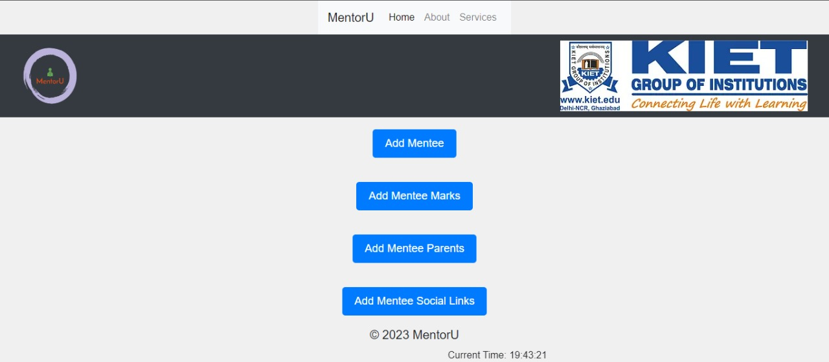

Fig:5.4 Add Mentee Details:

The dashboard features an overview section displaying mentee details, including the mentee's name, profile image, academic progress.

**1. Add Mentee:**

A prominent "Add Mentee" button allows mentees to initiate the process of adding a new mentee to their mentoring circle. Clicking this button opens a form to input mentee details and establish a new mentoring relationship.

**2. Add Mentee Marks:**

A dedicated section enables mentees to input and track their academic progress. The "Add Mentee Marks" option allows mentees to record grades, achievements, and other academic milestones.

**3. Add Mentee Parents:**

Mentees have the option to add information about their parents or guardians.

**4. Add Mentee Social Links:**

To encourage social connectivity and networking, mentees can add their social media links. The "Add Mentee Social Links" option allows mentees to share their professional or academic profiles, enhancing communication and collaboration within the MentorU community.

**User Interface:**

The dashboard design maintains a clean and intuitive user interface with a responsive layout for optimal viewing on various devices.

This Mentee Details Dashboard is designed to empower mentees in managing their mentoring relationships, academic progress, and overall engagement within the MentorU platform.

**Add Mentee:**

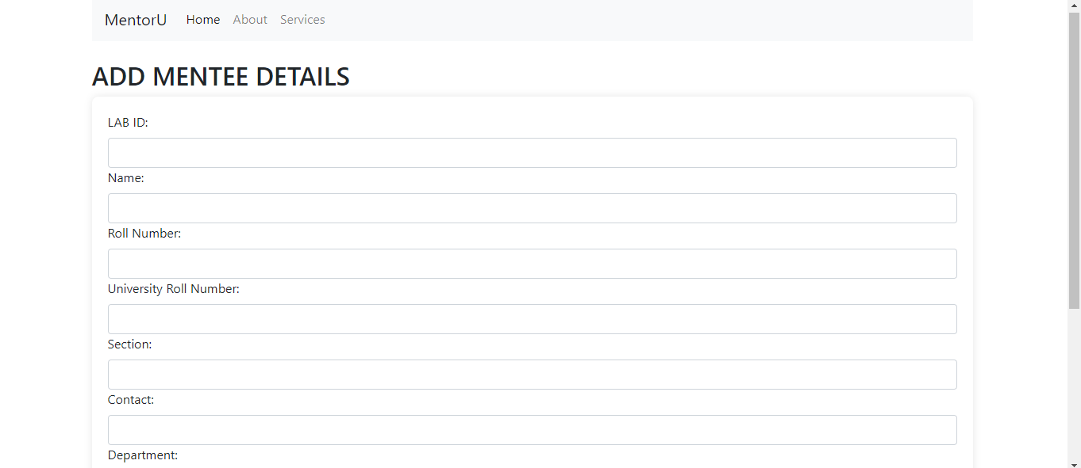

Fig:5.5 Add Mentee

Mentors have the ability to efficiently add mentees to their mentoring circle through a dedicated "Add Mentee" dashboard, streamlining the onboarding process.

**1. Mentee LAB ID:**

A unique identification number or code assigned to each mentee. Mentors can input or generate a mentee ID for easy reference.

**2. Name:**

A text input field for mentors to enter the mentee's full name, ensuring accurate identification.

**3. Roll Number:**

Mentors can input the mentee's class roll number, facilitating academic tracking and organization.

**4. University Roll Number:**

A specific field for mentors to input the mentee's university roll number, aiding in academic record management.

**5. Section:**

A text input field allowing mentors to specify the section or academic group to which the mentee belongs.

**6. Contact:**

A text input field for mentors to input the mentee's contact information, facilitating seamless communication.

**7. Department:**

A dropdown or text input field enabling mentors to specify the department or field of study to which the mentee is affiliated.

**8. Submit Button:**

A prominent "Submit" button finalizes the mentee addition process, saving the provided information to the mentor's dashboard.

**Validation Checks:** The form incorporates validation checks to ensure accurate and complete information is provided for each mentee.

**Error Handling:** Clear error messages are displayed if any required fields are left blank or if there are formatting issues.

Success Confirmation: Upon successful mentee addition, mentors receive a confirmation message or notification.

**User Interface:**

The dashboard maintains a clean and user-friendly interface, ensuring mentors can easily navigate the form and provide necessary details.

Clear labels, input fields, and intuitive design elements enhance user interaction, facilitating a seamless mentee addition process for mentors within MentorU.

**Add Marks:**

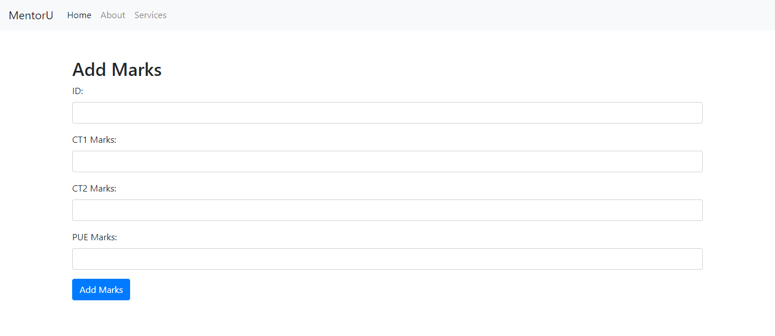

Fig:5.6 Add Marks

**Add Marks Form:**

The dashboard prominently features an "Add Marks" form with fields for essential academic details.

**1. Mentee ID:**

A unique identification number or code assigned to each mentee, serving as a reference for academic record tracking.

**2. CT1 Marks:**

A numeric input field where mentors can enter the mentee's marks for CT1 exam.

**3. CT2 Marks:**

A numeric input field for mentors to input the mentee's marks for CT2 exam.

**4. PUE Marks:**

A numeric input field allowing mentors to enter the mentee's marks for PUE exam.

**5. Submit Button:**

A prominent "Add Marks" button finalizes the mark addition process, saving the provided information to the mentor's dashboard.

Validation Checks: The form incorporates validation checks to ensure accurate and valid marks are provided for each category.

**Error Handling:** Clear error messages are displayed if any required fields are left blank or if there are formatting issues.

**Success Confirmation**: Upon successful addition of marks, mentors receive a confirmation message or notification.

**Add Parent Details:**

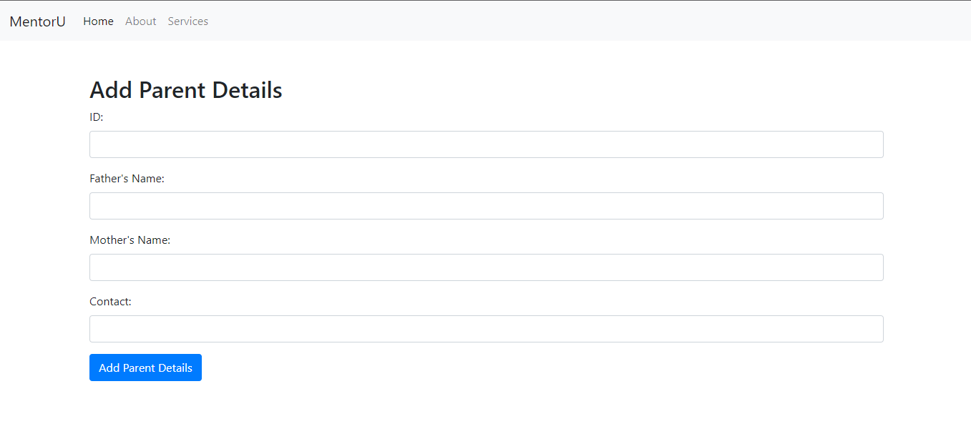

Fig:5.7 Add Parent details

**Add Parent Details Form:**

The dashboard prominently features an "Add Parent Details" form with fields for essential information about the mentee's parents.

**1. Mentee ID:**

A unique identification number or code assigned to each mentee, serving as a reference for parent details tracking.

**2. Father's Name:**

A text input field for mentors to enter the name of the mentee's father.

**3. Mother's Name:**

A text input field for mentors to enter the name of the mentee's mother.

**4. Contact:**

A text input field allowing mentors to input contact information for the mentee's parents or guardians.

**5. Submit Button:**

A prominent "Add Parent Details" button finalizes the addition of parent details, saving the provided information to the mentor's dashboard.

**Validation Checks**: The form incorporates validation checks to ensure accurate and complete information is provided for each parent detail.

**Error Handling**: Clear error messages are displayed if any required fields are left blank or if there are formatting issues.

**Success Confirmation**: Upon successful addition of parent details, mentors receive a confirmation message or notification.

**Profile Links:**

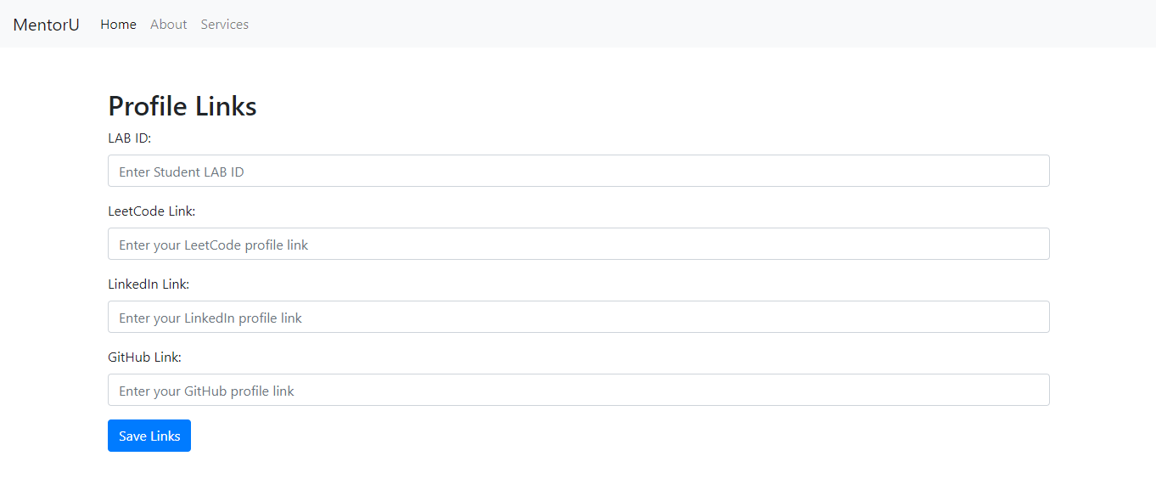

Fig:5.8 Profile Links

**Profile Links Form:**

The dashboard prominently features a "Profile Links" form with fields for essential links related to the mentee's professional presence.

**1. Mentee ID:**

A unique identification number or code assigned to each mentee, serving as a reference for profile links tracking.

**2. LeetCode Link:**

A text input field for mentors to input the mentee's LeetCode profile link.

**3. LinkedIn Link:**

A text input field for mentors to input the mentee's LinkedIn profile link.

**4. GitHub Link:**

A text input field for mentors to input the mentee's GitHub profile link.

**5. Submit Button:**

A prominent "Save Links" button finalizes the addition of profile links, saving the provided information to the mentor's dashboard.

**Validation Checks:** The form incorporates validation checks to ensure accurate and properly formatted links are provided for each category.

**Error Handling:** Clear error messages are displayed if any required fields are left blank or if there are formatting issues with the links.

**Success Confirmation:** Upon successful addition of profile links, mentors receive a confirmation message or notification.

**Mentees List:**

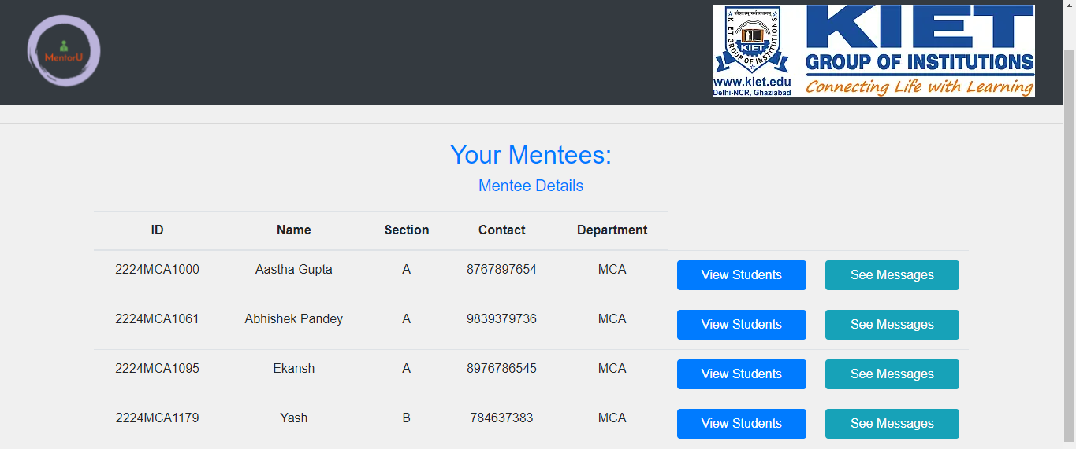

Fig:5.9 Mentees List

**Mentees List Overview:**

The dashboard displays a table or list showcasing mentees' details, including unique IDs, names, sections, Contact and Department. This provides mentors with a quick overview of their mentee cohort.

**1. View Details Option:**

Mentors can click on the "View Students" option next to each mentee's entry to access a detailed profile, including academic progress, parent details, profile links, and other relevant information.

**2. See Messages Option:**

An additional "See Messages" option allows mentors to access a communication log or inbox specific to each mentee. This feature facilitates seamless communication between mentors and mentees within the MentorU platform.

**User Interface:**

The dashboard maintains a clean and user-friendly interface, presenting mentee details in an organized and visually appealing manner.

Clear labels, intuitive design elements, and responsive layout enhance user interaction, ensuring mentors can efficiently navigate and manage their mentees within MentorU.

**Mentee details:**

Fig:5.10 Mentee details

Mentors have access to a comprehensive "Mentee Details" dashboard, providing a holistic view of mentee information, parent details, links, previous counselling, semester marks, attendance, and performance details.

**Basic Mentee Information:**

Display of mentee's full details, including name, roll number, university roll number, lab ID, section, contact, and session information.

**Parent Details:**

Father's name, mother's name, and contact details of the mentee's parents or guardians are prominently displayed.

**Profile Links:**

Links to the mentee's GitHub, LinkedIn, and LeetCode profiles for easy access to their professional presence.

**Previous Counselling Details:**

Number of counselling sessions attended, previous counselling date, and an option for mentors to provide remarks. Additionally, a button to connect for further discussions.

**Semester Marks:**

Display of academic performance, including marks for CT1, CT2, PUE (Practical and Understanding Examination), and overall semester performance.

**Attendance and Performance Details:**

Information on attendance records and performance details to give mentors insights into the mentee's academic standing.

**Counselling Details Form:**

A dedicated form to input upcoming counselling date, counselling type, counselling suggestion, and the option to upload any relevant achievement documents.

**Submit Button:**

A prominent "Submit" button finalizes the counselling details, updating the mentee's profile with the latest information.

**Connect Button:** Allows mentors to initiate communication with the mentee directly from the dashboard.

**Document Upload**: Enables mentors to receive and store any relevant achievement documents shared by the mentee during counselling sessions.

**Dynamic Display:** Sections are collapsible or expandable to keep the dashboard clean and organized.

**User Interface:**

The dashboard maintains a clean and user-friendly interface, presenting mentee details in a structured and visually appealing manner.

Clear labels, intuitive design elements, and responsive layout enhance user interaction, ensuring mentors can efficiently navigate and understand mentee details within MentorU.

**Mentee dashboard:**

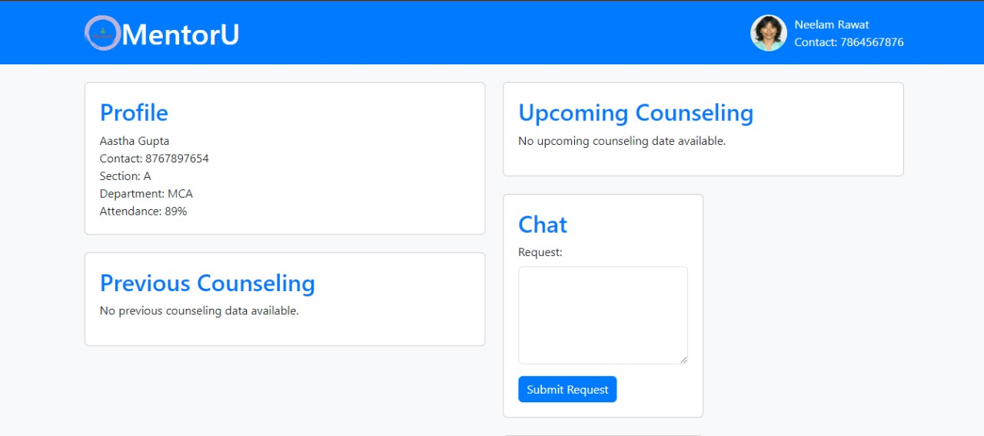

Fig:5.11 Mentee dashboard

**Mentee Dashboard:**

Mentees have access to a personalized and informative dashboard that displays mentor details, mentee profile information, counselling history, upcoming sessions, and a chat option for queries.

**1. Mentor Details Section:**

The dashboard prominently features details about the assigned mentor, including their name and contact information.

**2. Mentee Profile Display:**

The mentee's profile is showcased, featuring important details such as name, contact information, section, department, and attendance records. This section provides a quick overview of the mentee's academic and personal information.

**3. Counselling History:**

A section displays the mentee's previous counselling sessions, including details such as the date, feedback, and any action items assigned during the session.

**4. Upcoming Counselling Date:**

The dashboard highlights the date and time of the next scheduled counselling session. This information ensures mentees are well-prepared and aware of their upcoming mentoring interactions.

**5. Chat Option for Queries:**

A dedicated chat feature allows mentees to communicate directly with their mentor for any queries, concerns, or additional support needed. This real-time communication channel facilitates seamless interaction between mentees and mentors.

**6. Logout:**

A "Logout" button, located at the top-right corner, ensures mentees can securely log out of their accounts when needed.

**Additional Features:**

Attendance Records: The dashboard includes a section displaying the mentee's attendance records, providing insights into their academic engagement.

Profile Picture Display: If available, the mentee's profile picture is displayed for easy identification and personalization.

CONCLUSION

In conclusion, the development of MentorU, an innovative online mentorship platform, signifies a transformative step in addressing the evolving landscape of education and professional development. With careful consideration in design and implementation, MentorU provides a dynamic and interactive virtual environment connecting mentors and mentees.

The platform's primary focus on fostering meaningful mentor-mentee relationships within the college community is evident through its features. The login system enables mentors to easily manage their mentees, monitor academic and professional progress, respond to queries, provide remarks, and schedule mentoring sessions through platforms like Google Meet. Simultaneously, mentees can access a centralized space to view mentor details, pose queries, and attend scheduled mentorship sessions.

As MentorU advances, continuous refinement will be crucial to adapt to emerging educational trends and technological advancements. Incorporating features such as AI-driven personalized recommendations, optimizing mobile compatibility for flexibility, and ensuring robust security measures will contribute to the platform's continued success.

In essence, MentorU not only represents a technological solution but also a catalyst for revolutionizing mentorship practices, promoting accessibility, and building a supportive community within educational institutions. The platform's commitment to enhancing the academic journey of students reflects its potential to redefine mentorship dynamics and contribute to the broader landscape of online education and professional development**.**

**BILIOGRAPHY**

**1.** GitHub. "GitHub - Version Control and Collaboration Platform." https://github.com/.

1. W3Schools. "W3Schools - Web Development Tutorials." https://www.w3schools.com/.

**3.** Wikipedia. "Wikipedia - The Free Encyclopaedia." https://www.wikipedia.org/.

**4.** Stack Overflow. "Stack Overflow - Question and Answer Community for Programmers." https://stackoverflow.com/.